dvAgendaSection
ITEM NUMBER dvItemNumberMasked
SUBJECT dvSubjectWithSoftReturns
REFERENCE dvEDMSContainerId - dvFileNumber
REPORT OF dvAuthors

LAND OWNER: Australian Unity Investment management Administration pty. ltd.

APPLICANT: investa office developments

PURPOSE:

This report requests the Local Planning Panel recommend to Council that it endorse a Planning Proposal for the land at 10 Valentine Avenue, Parramatta and that the Planning Proposal be forwarded to the Department of Planning and Environment for a Gateway Determination. The report also requests the Panel recommend to Council that it endorse the preparation of a site-specific Development Control Plan to manage the built form and public domain in association with the Planning Proposal.

RECOMMENDATION

That the Local Planning Panel recommend to Council:

(a) That Council endorse the Planning Proposal included at Attachment 1 subject to the inclusion of a site-specific LEP clause that applies the maximum car parking rates endorsed as part of the CBD Planning Proposal.

(b) That Council authorises the CEO to prepare and exhibit a site-specific DCP which provides for a maximum podium height at 25.0m AHD in accordance with the existing development consent (DA/841/2017). The DCP should also require the footpath design to be capable of being narrowed if Valentine Avenue is converted to two-way traffic in the future.

(c) That the Planning Proposal be forwarded to the Department of Planning and Environment with a request for a Gateway determination.

(d) That Council advise the Department of Planning and Environment that the CEO will be exercising the plan-making delegations for this Planning Proposal as authorised by Council.

(e) Further, that Council authorises the CEO to correct any minor anomalies of a non-policy and administrative nature that may arise during plan amendment processes.

SITE

- The subject site is located at 10 Valentine Avenue, Parramatta and has a legal description of Lot 2 DP 1119257 (Refer to Figure 1). The site has an area of 3,935 square metres. The site contains a commercial building within the northern part of the site and a multi-storey car park within the southern part of the site.
- The site adjoins the western railway line to the north and east and Valentine Avenue to the West.
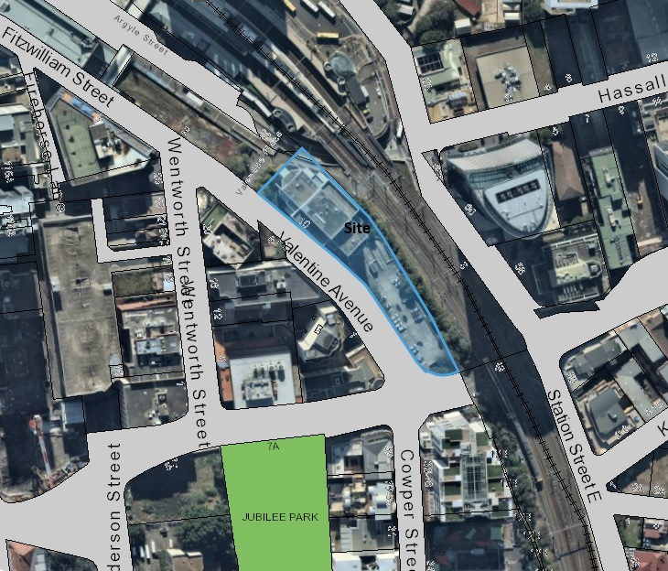

Figure 1: Location Map (Source: City of Parramatta)

CURRENT PLANNING CONTROLS

- Under the Parramatta Local Environmental Plan 2011 (PLEP 2011) the site is subject to the following controls:
  - Land Use Zoning is B3 Commercial Core;
  - Floor Space Ratio (FSR) is 6:1;
  - Height of Buildings is 54 metres; and
  - The site is not listed as an item of heritage significance and is not within a Heritage Conservation Area. The site is near the Parramatta Railway Station which is listed as an item of State heritage significance and is also listed on the State Heritage Register.

DESIGN COMPETITION AND DEVELOPMENT APPLICATION HISTORY

- The site contains a commercial building within the northern part of the site and a multi-storey car park within the southern part of the site (Refer to Figure 2 below). The applicant proposes to retain the existing commercial building and develop the southern part of the site containing the existing car park.
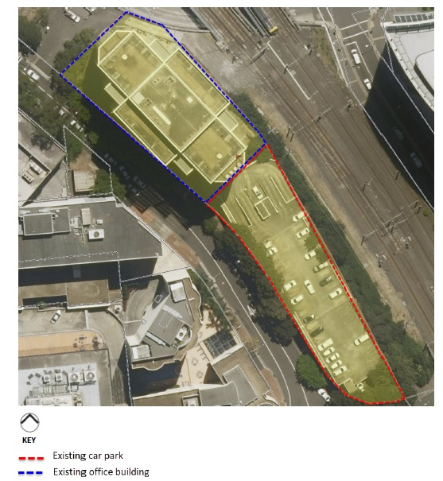
Figure 2: Aerial photo showing existing building to the north proposed to be retained and existing car park to the south proposed to be redeveloped. (Source: Applicant’s Planning Proposal, Robinson Urban Planning)

- The site was subject to a Design Competition in 2017 under the existing Design Excellence provisions of the PLEP 2011. The Design Competition was predicated on the basis of a Scheme 1 and Scheme 2 design. Scheme 1 reflects the existing PLEP 2011 controls in relation to height and FSR and Scheme 2 reflects the proposed controls endorsed by Council under the CBD Planning Proposal. The applicant’s intention was to proceed with construction based on Scheme 1 design (which also has DA approval) and to follow up with a further application to add additional floors to the building under the Scheme 2 design upon finalisation of the CBD Planning Proposal.
- The Design Jury awarded design excellence to the preferred scheme in August 2017 which was a design by Fitzpatrick + Partners. Figures 3 and 4 below show Scheme 1 and Scheme 2 of the winning design.

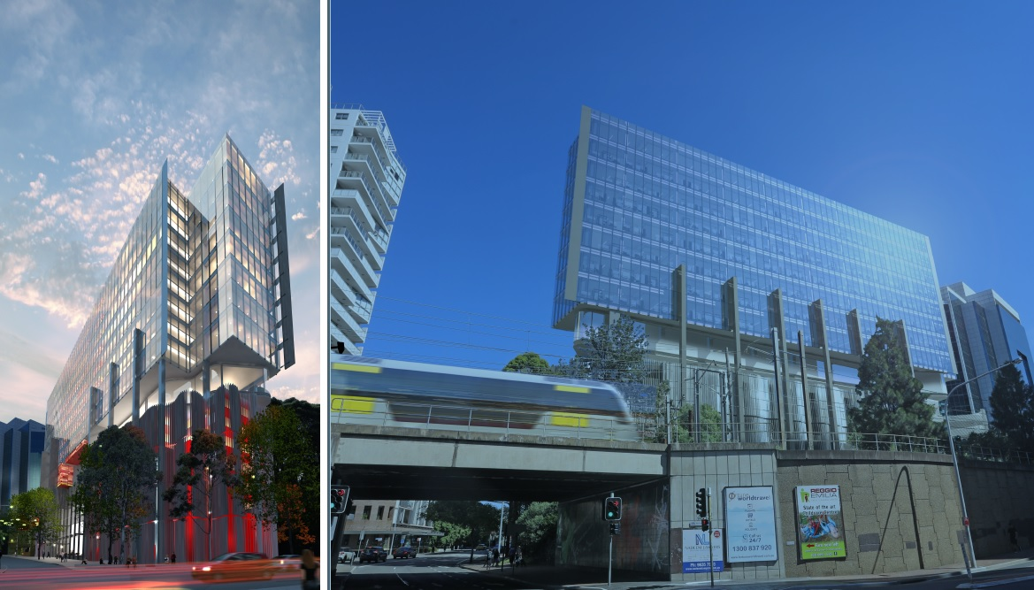
Figure 3: Scheme 1 of the winning design reflecting existing PLEP 2011 controls (FSR of 6.9:1 and HOB of 62.1m including Design Excellence Bonus) (Source: Applicant’s Design Competition submission, Fitzpatrick + Partners)

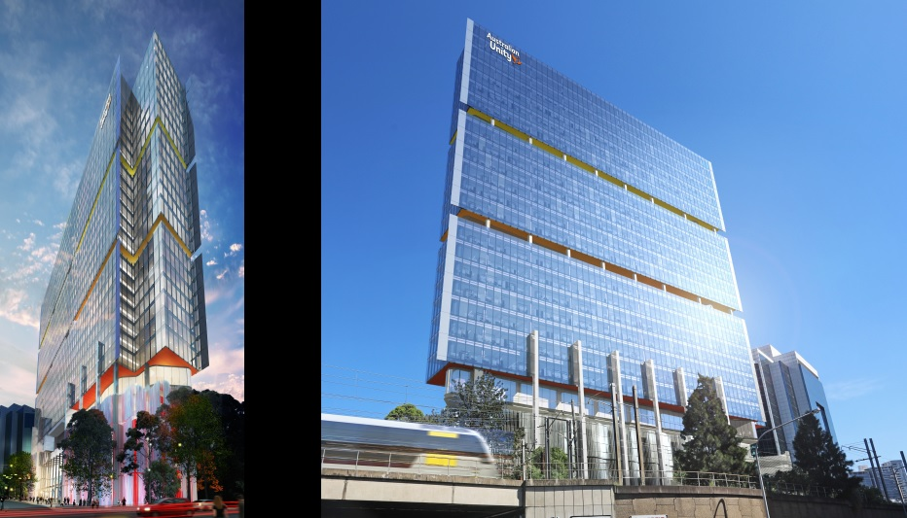
Figure 4: Scheme 2 of the winning design reflecting CBD Planning Proposal controls (FSR of 11.19:1 and HOB of 116.2m including Design Excellence Bonus). (Source: Applicant’s Design Competition Submission, Fitzpatrick + Partners)

- A Development Application (DA/841/2017) was subsequently approved on 10 April 2018 which relates to a 14-storey building in accordance with Scheme 1 of the Design Competition winning design. The applicant’s original intention was to wait until the new planning controls under the CBD Planning Proposal were in place before lodging a second development application for the additional height and FSR under Scheme 2 of the winning design. However, due to the length of time taken to receive a Gateway Determination for the CBD Planning Proposal, they have decided to lodge a site-specific Planning Proposal.
- On 14 June 2018, the applicant lodged a Section 4.55 modification application (formerly known as Section 96) seeking to amend the development consent to remove condition 42 requiring external solar shading. At the time of preparing this report, this application had yet to be determined.
- On 18 June 2018, the applicant lodged a second Section 4.55 modification application seeking several changes to the consent including a 3.8 metre building height increase and an additional level of car parking.
- Council’s Development and Traffic Services Unit wrote to the applicant and advised that the second modification application was likely to be refused for the following reasons:
  - Parramatta Development Control Plan 2011 (DCP 2011) requires car parking to be below ground. If car parking is to be above ground, it should be sleeved with active uses.
  - The assessment of the original development application noted that car parking cannot be provided underground due to the location of the future railway corridor and it also cannot be sleeved due to the narrow width of the site.
  - Council accepted the unsleeved, aboveground car parking due to the constraints of the site but noted the potential for an adverse visual impact and required that the podium car park be no higher than the existing car parking structure.
  - It was considered that there was no justification for exceeding the already approved podium height, which already reflected a compromised position.
- The applicant subsequently withdrew the section 4.55 modification application.

PLANNING PROPOSAL

- The applicant’s planning proposal (refer to Attachment 1) seeks to amend PLEP 2011 by:
  - Increasing the FSR on the Floor Space Ratio Map from 6:1 to 10:1;
  - Amending the Height of Buildings (HOB) Map by removing the 54 metres height limit that currently applies to the site;
  - Inserting a site-specific clause that exempts office premises from the FSR calculation; and
  - Inserting a site-specific clause that prohibits the subdivision of the aboveground car parking.
- A table summarising the existing planning controls, controls sought by the Planning Proposal and those endorsed by Council under the CBD Planning Proposal is included in Table 1 below.

Control | Existing (PLEP 2011) | Applicant’s Planning Proposal | Parramatta CBD Planning Proposal – draft proposed controls
Height | 54m  (approximately 14 storeys) | Remove the height control  (reference design is 123.5m or 32 storeys) | No height control, however, subject to Clause 7.4 sun access protection (relating to Jubilee Park)
FSR | 6:1 | 10:1 (11.5:1 including Design Excellence)  (reference design is 13.25:1 across the whole site when taking into account the existing office building which is to remain on site) | 10:1 (11.5:1 including Design Excellence)
Site-specific provision |  | Office premises are exempt from FSR calculation in B3 zone | Office premises are exempt from FSR calculation in B3 zone
Table 1: Table comparing the existing planning controls, controls sought by the Planning Proposal and those endorsed under the CBD Planning Proposal.

- The proposal is consistent with Council CBD Planning Proposal and relevant State Government Policies. In particular, the delivery of additional commercial floor space is consistent with the policy framework that seeks to maximise jobs growth in the Parramatta CBD. The strategic alignment is dealt with in detail in Part 3 and Section B of the Planning Proposal document included as Attachment 1.
- The applicant’s Planning Proposal includes the following documentation:
  - Planning Proposal (Attachment 1);
  - Urban Design Statement (Attachment 2);
  - Applicant’s LEP drafting instructions;
  - Site survey;
  - Preliminary Geotechnical Site Investigation;
  - Geotechnical Investigation;
  - Flood Study;
  - Wind Tunnel Report
  - Traffic Report; and
  - Parramatta to Epping Rail Link drawings and overlays.

Applicant’s proposed development concept

- The standard process when Planning Proposals are exhibited is for the Planning Proposal to be supported by a reference design that shows the potential scale of a future development that is consistent with the proposed new controls being considered. This proposed development concept includes two reference designs. They reflect two possible development application scenarios that may occur. This approach was recommended by Council Officers to transparently communicate to Council and the community the possible approaches to the development that could be taken by the proponent given that a Development Approval has already been granted for the subject site.
- Reference Design 1 reflects a scenario where the applicant proposes commences building that development approved under the existing development consent (DA/841/2017) and then applies for a development application for additional storeys permitted under the Planning Proposal. The development would then occur under two consents being the original existing consent for the lower floors and the second future consent for the upper floors.
- Reference Design 1 proposes:
  - A 31 storey (120 metre high) freestanding tower comprising:
    - 6 levels of aboveground car parking;
    - 21 levels of commercial floor space providing 30,746 square metres of office space;
    - 3 levels of terrace/end-of-trip facilities and 1 level for plant.
- The applicant’s reference design 1 is shown in Figures 5, 6 and 7 below.

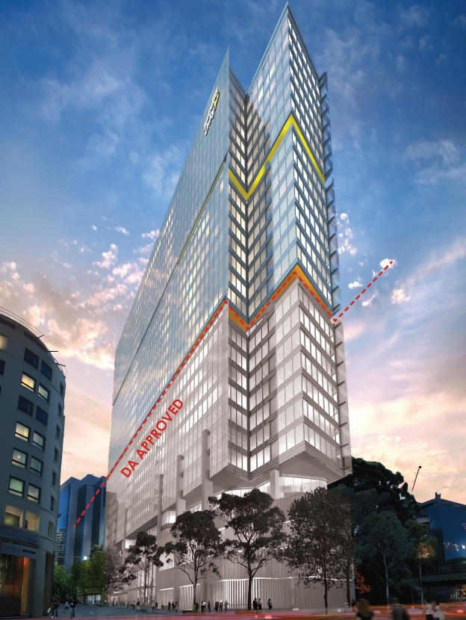
Figure 5: Applicant’s design concept (Reference Design 1) when viewed from the south (Source: Applicant’s Urban Design Report, Fitzpatrick + Partners)

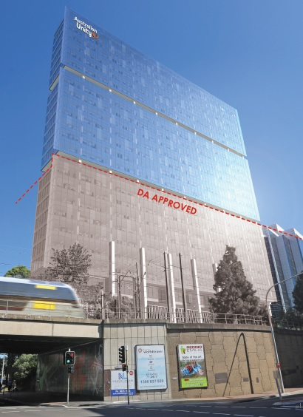
Figure 6: Applicant’s design concept (Reference Design 1) when viewed from the east (Source: Applicant’s Urban Design Report, Fitzpatrick + Partners)
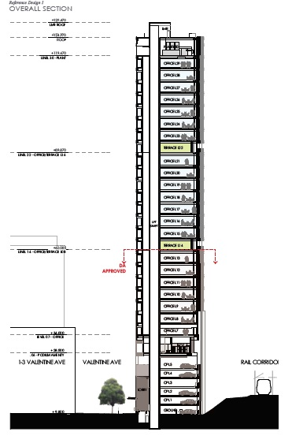
Figure 7: Applicant’s Urban Design concept (Reference design 1) east-west section (Source: Applicant’s Urban Design report, Fitzpatrick + Partners)

- Reference Design 2 reflects a scenario where the applicant proposes a new building that has no relationship to the building that is subject to the existing development consent. The application would be a new development application as permitted by the Planning Proposal for the entire building. Reference Design 2 proposes:
  - A thirty-one storey (120 metre high) freestanding tower comprising:
    - 3 levels of above ground car parking;
    - 24 levels of commercial floor space providing 34,522sqm of office space; and
    - 3 levels of terrace/end of trip facilities and 1 level for plant.
- The applicant’s reference design 2 is shown in Figures 8, 9 and 10 below.

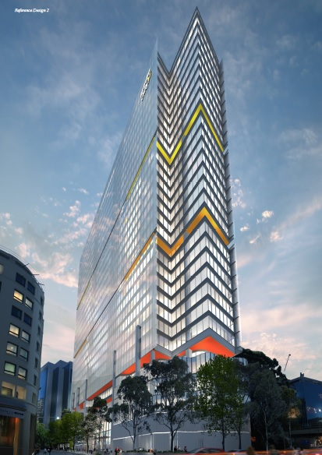
Figure 8: Applicant’s design concept (Reference Design 2) when viewed from the south (Source: Applicant’s Urban Design Report, Fitzpatrick + Partners)

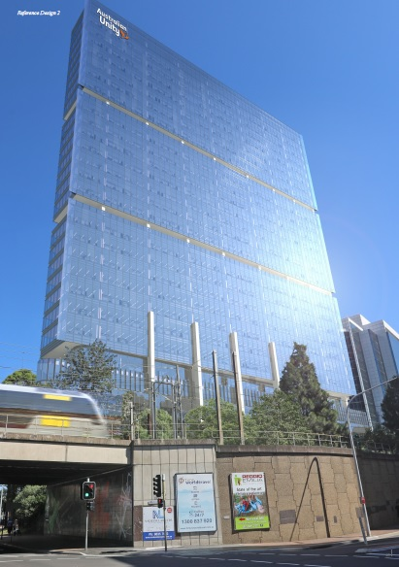
Figure 9: Applicant’s design concept (Reference Design 2) when viewed from the east (Source: Applicant’s Urban Design Report, Fitzpatrick + Partners)
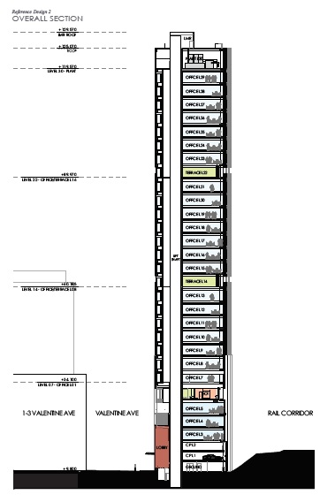
Figure 10: Applicant’s Urban Design concept (Reference design 2) east-west section (Source: Applicant’s Urban Design report, Fitzpatrick + Partners)

KEY ISSUES

Car parking

- The difference between Reference Design 1 and Reference Design 2 relates to the land uses within the podium. The podium for Reference Design 1 consists of 6 levels of aboveground car parking. The podium for Reference Design 2 consists of 3 levels of aboveground car parking and 3 levels of office space.
- A table summarising the car parking spaces under different scenarios is provided in Table 2 below.
Car Parking
 | Existing Building | New Building | Total
Existing concrete car park (to be demolished). | 285
Car parking within existing commercial building (to be retained) | 27
Reference Design 1 | 27 | 135 | 162
Reference Design 2 | 27 | 41 | 68
Note: The car parking rates endorsed under the CBD Planning Proposal allow for a total of 79 car parking spaces.
Table 2: Table summarising car parking numbers under the different scenarios

- As shown in the table in Table 2 above, Reference Design 1 does not comply with the CBD Planning Proposal in relation to car parking numbers. Reference Design 2 does comply. However, it is acknowledged that there is an approved development application for a building that includes 135 car spaces in the podium, which is relevant to the assessment of the Planning Proposal. It is possible that the applicant may decide to proceed with the approved development application and lodge a second development application for additional storeys above the approved building (Reference Design 1). If construction has already commenced under the existing approval, it would not be preactival to require an amendment to the existing approval to reduce the car parking on site when the Planning Proposal is finalised. The existing approval with the approved parking would remain valid and the new application for additional floor space with no additional parking would be assessed against the controls in place at the time it is lodged.
- However, if the current development application is not activated and a new application is lodged for a new building without relying on the original consent (Reference Design 2), the CBD Planning Proposal car parking rates would be applied. Should the Planning Proposal be endorsed by Council to seek a Gateway determination, it is recommended that a site-specific clause be included which applies the maximum car parking rates endorsed as part of the CBD Planning Proposal.
- Reference Design 1 provides for 135 car parking spaces (total of 162 car parking spaces when including 27 spaces within the remaining building at 10 Valentine Avenue) which is consistent with existing policy controls. Reference Design 2 provides for 41 car parking spaces (total of 68 car parking spaces when including 27 spaces within the remaining building at 10 Valentine Avenue) which is consistent with the CBD parking rates endorsed by Council under the CBD Planning Proposal.

Urban Design

- Council’s City Architect’s team and Urban Design team have assessed the Planning Proposal and noted that the height and floor space of the Planning Proposal is consistent with the Parramatta CBD Planning Proposal and also the winning Design Competition design (DC/18/2016). As such, no objection is raised to the Height and FSR sought in the Planning Proposal.
- With regard to the reference design, concerns were raised with the initial reference design submitted with the Planning Proposal. Council’s City Architect’s team noted that during the course of the assessment of the development application which followed the Design Competition (DA/841/2017) a negotiated position was reached on the following:
  - The floor-to-floor height of the aboveground car parking levels;
  - The number of aboveground car parking levels; and
  - The overall podium height.
- The applicant’s Urban Design Report references the DCP podium height control (26 metres above natural ground) as being the relevant benchmark for their site. However, the primary concern with the podium height is the nature of the podium itself which contains car parking. The Parramatta DCP 2011 seeks to avoid aboveground car parking in the CBD where possible. Where basement car parking is not possible, the aboveground car parking should be sleeved with other uses (ie in this case commercial floor space) to avoid blank walls being presented to the street..
- Basement car parking is not practical on this site due to the existence of the Parramatta to Epping Rail Protection Corridor (PERL). This protected corridor may ultimately be used for another infrastructure project, potentially the Sydney Metro West, however, notwithstanding this, the protected corridor precludes the construction of basement car parking for this site. Sleeving is also not possible or practical due to the site’s narrow width.
- Given these constraints, it is considered acceptable in this case, for car parking to be provided in the podium. However, the visual impacts of this need to be managed appropriately and minimised. For this reason, the assessment of the development application reached a position where the overall podium height was limited to that of the existing concrete car parking structure (25.0m AHD). This resulted in 6 levels of aboveground car parking in total.
- No objection is raised to the revised reference designs (Reference Design 1 and Reference Design 2). It is noted that if a new development application is lodged in the future that has no relationship to the original consent, a new design competition will be required. As such, it is appropriate to prepare a site-specific DCP to accompany the Planning Proposal that prescribes a maximum podium height of 25.0m AHD as identified through the assessment of the previous development application.
Heritage
- The site is near Parramatta Railway Station which is listed heritage item of State Significance. Council’s Heritage Advisor notes that the Planning Proposal is consistent with the Parramatta CBD Planning Proposal and has raised no objection.

Flooding
- The southern tip of the site is subject to the 1 in 100 year Average Recurrence Interval flood level. The issue of flooding was addressed as part of the development application where it was noted that the proposed building floor levels and vehicular access points have been designed to be above the relevant flood level. Conditions of consent were imposed on the consent (DA/841/2017) to ensure the building appropriately responds to flood risk.
Overshadowing
- Clause 7.4 (Sun Access) of the Parramatta LEP 2011 brings into consideration the sun access plane controls of the Parramatta DCP 2011. This requires development to not overshadow Jubilee Park between 12 pm and 2pm on 22 June. The shadow diagrams submitted by the applicant with the Planning Proposal indicate that the Planning Proposal complies with this requirement.
Traffic and Transport
- Council’s Traffic and Transport team commented on the Planning Proposal and provided the following comments:
  - The number of car parking spaces in the proposed building should comply with the maximum car parking rates under the Parramatta CBD Planning Proposal.
  - While Valentine Avenue is currently a one-way street at present, it is possible that there may be interest in converting it to two-way traffic in the future.
- With regard to (a) above, this issue is noted and was discussed previously under the heading “Summary of car parking differences Between Reference Design 1 and Reference Design 2”. With regard to (b) above, this issue was addressed through the assessment of the development application (DA/841/2017) which imposed a condition of consent which requires resubmission of the drawings prior to construction with the Council retaining the ability to require a narrower footpath area should two-way traffic in Valentine Avenue be considered appropriate in the future.
- To assist in the assessment of any future development applications, this requirement could also be included in a site-specific DCP as follows:
  - “The design of the footpath should:-
    - Show a narrower footpath if Council has made a decision to make Valentine Avenue a two-way street at the time the public plans are submitted to Council for endorsement; or
    - Designed in a way that facilitates the narrowing of the footpath if Council has not yet finalised its position on whether Valentine Avenue should change to a two way street.”

CONCLUSION
- The Planning Proposal is consistent with the Parramatta CBD Planning Proposal in relation to FSR and Height and is supported.
- It is considered appropriate that the Planning Proposal be endorsed for the purposes of seeking a Gateway determination, subject to the following inclusions and amendments:
  - The inclusion of a site-specific clause within PLEP 2011 that applies the maximum car parking rates endorsed by Council as part of the Parramatta CBD Planning Proposal.
  - The inclusion of a site-specific DCP which sets a maximum podium height at 25.0m AHD. The DCP should also require the footpath design to be capable of being narrowed if Valentine Avenue is converted to two-way traffic in the future.

CONSULTATION & TIMING

- If the Parramatta Local Planning Panel supports the recommendations of this report, a further report will be prepared for Council to seek adoption of the Local Planning Panel recommendation. If Council resolves to proceed with the Planning Proposal it will be forwarded to the Department of Planning and Environment for Gateway Determination.

- If a Gateway Determination is received, the Planning Proposal will be placed on public exhibition along with the site-specific DCP. A report on the outcomes of the public exhibition will be provided to the Local Planning Panel addressing any objections received. If no objections are received, the matter will be reported directly to Council seeking approval to finalise the Planning Proposal.

FINANCIAL IMPLICATION FOR COUNCIL

- There are no financial implications related to this matter and there is no Voluntary Planning Agreement associated with the Planning Proposal. A Voluntary Planning Agreement is not required to be entered into as the site is zoned B3 Commercial Core and residential development is not permissible. Under Council’s Voluntary Planning Agreements Policy fully commercial developments do not require a Voluntary Planning Agreement.

Felicity Roberts
Project Officer Land Use

Attachments:
1 | Applicant's Planning Proposal | 64 Pages
2 | Applicant's Urban Design Statement | 56 Pages

REFERENCE MATERIAL

